Mapper: separate data into key-value pair.

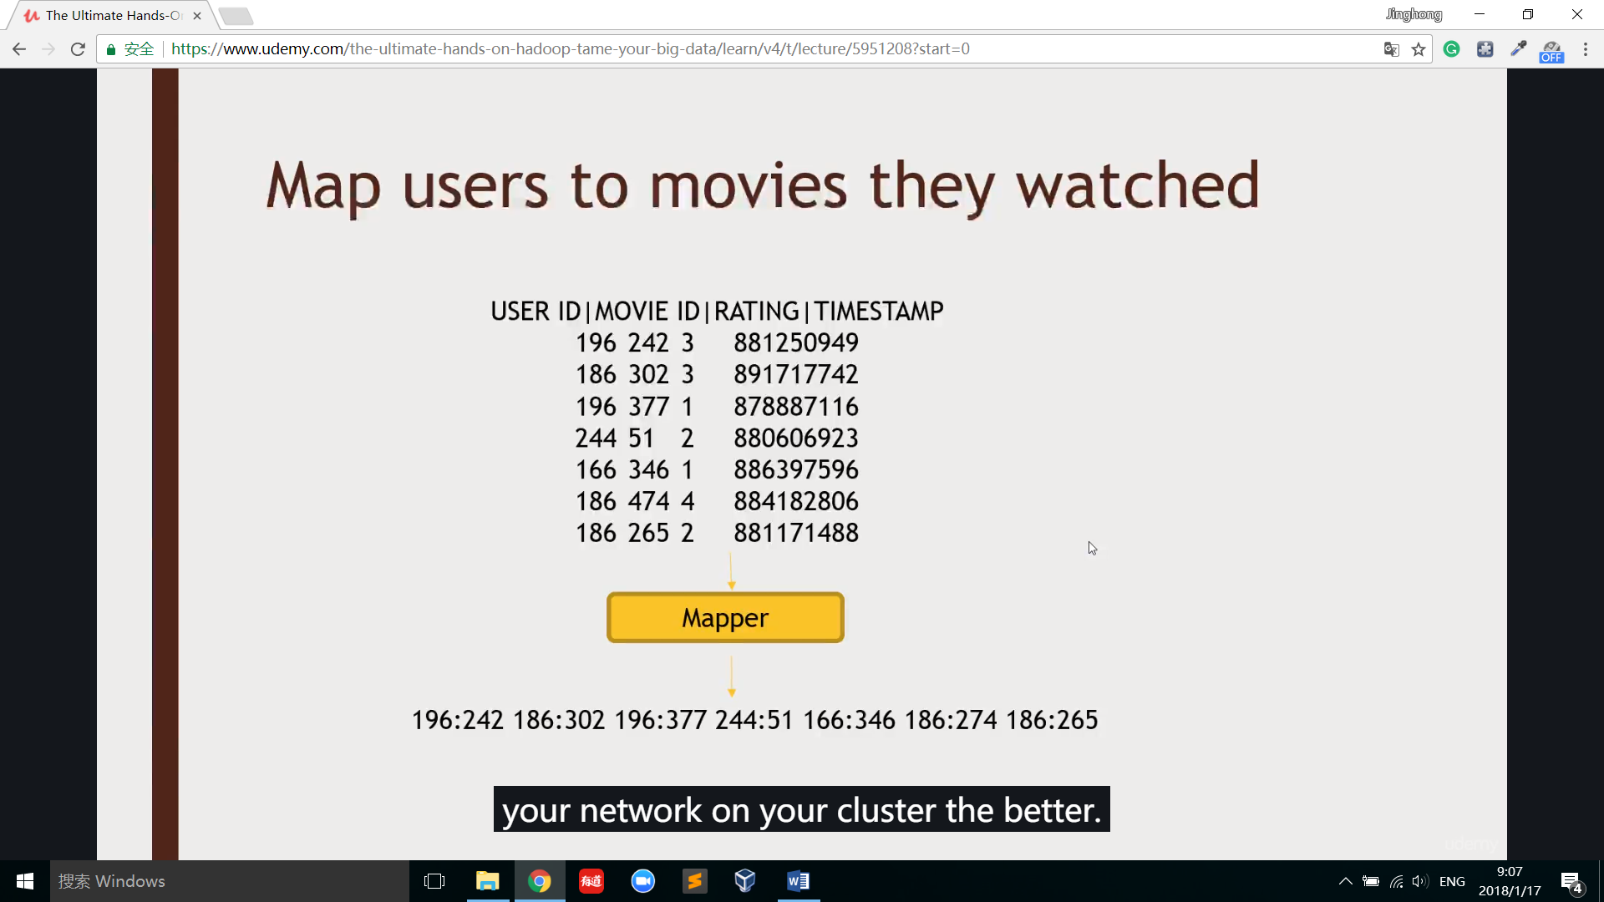

Shuffle and sort: look at all of the unique key-value pair and aggregates together value to the unique key.

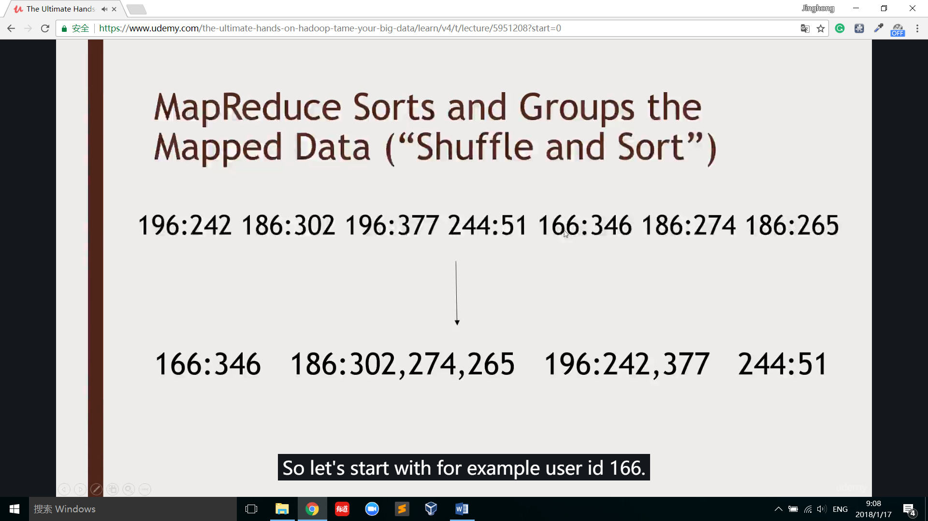

Reducer: decide what to do with those key-value pair output.

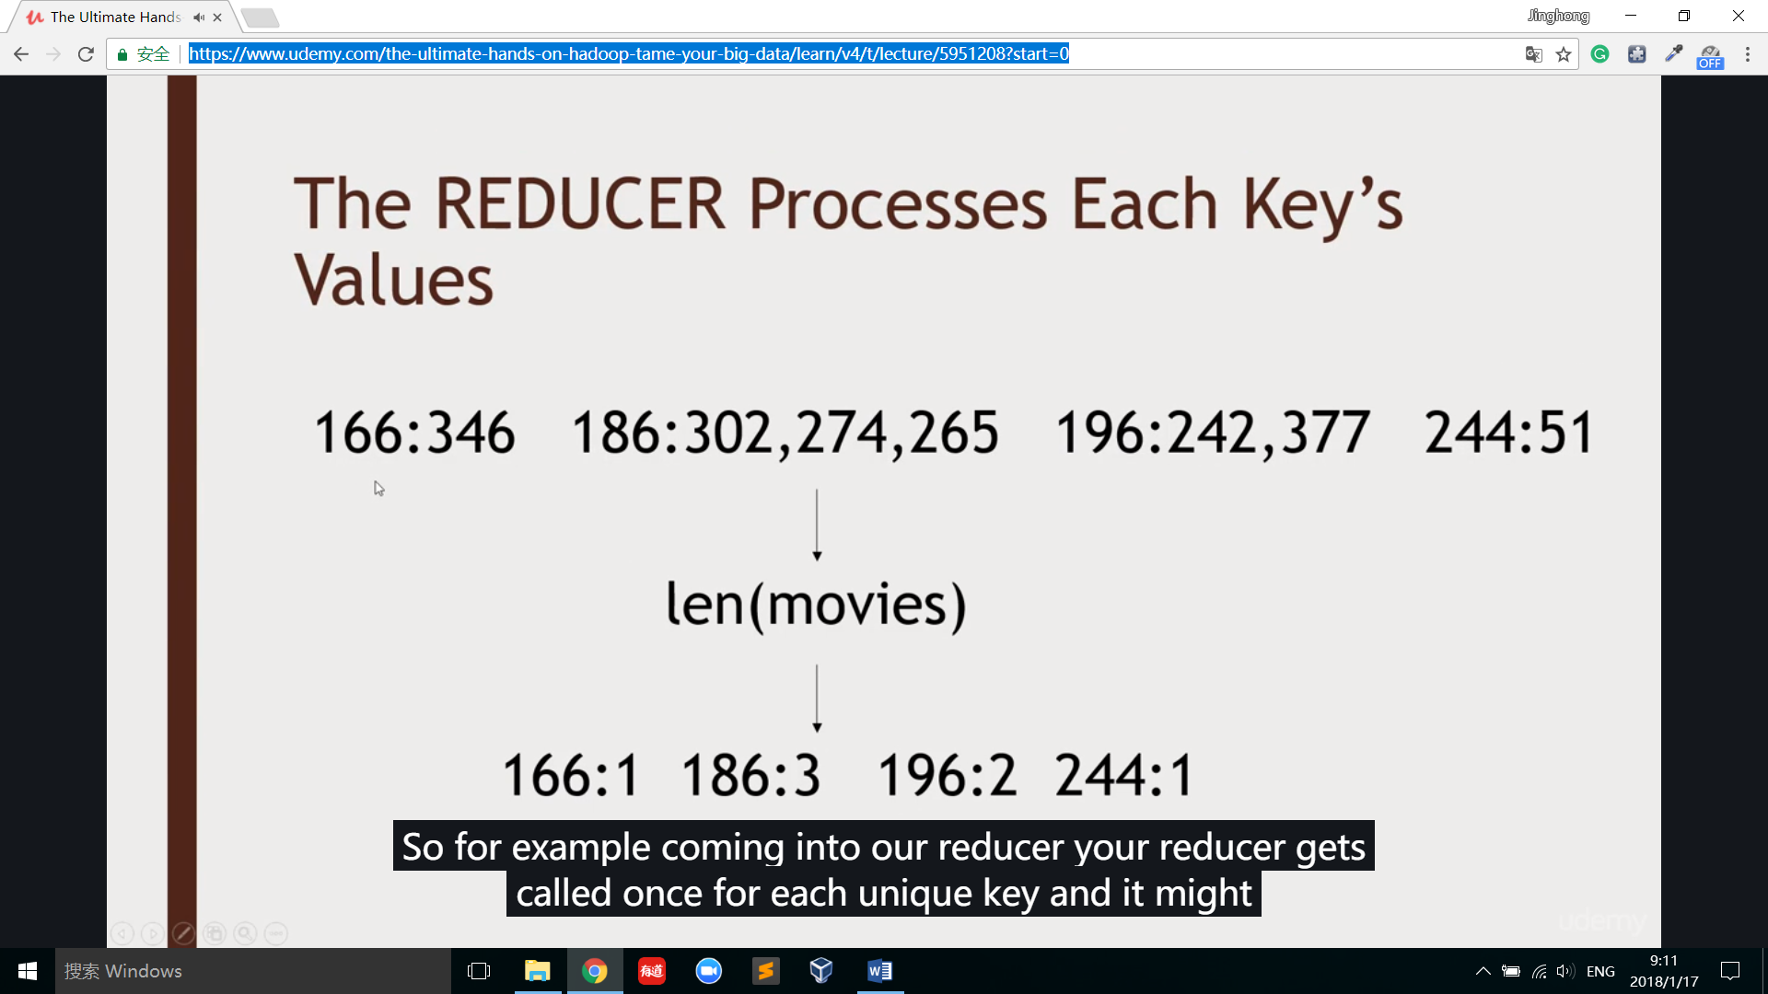

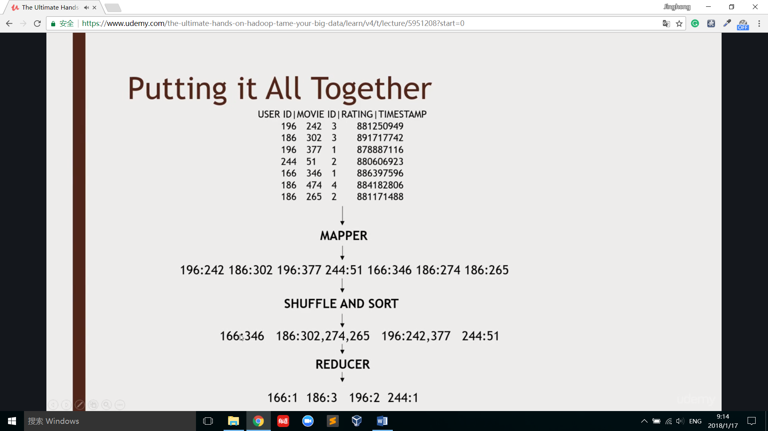

Python mapreduce example:

orderItemFile = open(“./file”)

orderItemRead = orderItemFile.read()

orderItems = orderItemRead.splitlines()

orderItemFilter = filter(lambda rec:int(rec.split(“,”)[1] == 68000,orderItems)

orderItemMap = map(lambda rec: float(rec.split(“,”)[4]),orderItemFilter)

orderItemReduce = reduce(lambda total,element:total+element,orderItemMap)